EXAM 2

CHEMISTRY 220

Friday, November 4, 2011

***Answer Key***

NAME (print): ________________________________________________________

TA:_________________ Sect. Day:_________________ Sect. Time:_____________

Fill in the information above. Place your name on the top right of subsequent pages.

Take a few moments to look over the exam. Record answers to questions on the exam paper.

No calculators, electronic devices or earbuds. You may use molecular models. Important clues and structures are in **bold**. A **Periodic Table** (pg. 8), a **pKa Table** (pg. 9)and a **Bond Dissociation Energy Table** (pg. 10) are provided.

Do all **preliminary** drawing or computations on the work sheets at the end of the exam. The work sheets will not be graded. You may detach the work sheets from the exam.

The exam is 55 minutes.

**STOP** writing and hand in your exam when you are asked to do so.

**Remember:** Neatness is to your advantage.

1. (30 pts) Thermochemistry ______

2. (40 pts) Potpourri (do 4 of 6) ______

3. (30 pts) Conformation ______

4. (20 pts) Reactions (2 of 4) ______

______________________________________________

Total (120 pts)

Your grade above will be scaled to 100 points.

1. **Thermochemistry:** (30 pts.)
2. (20 pts.) Provide the two propagation steps for the free radical monochlorination of cyclooctane using the bond dissociation energies in the BDE Table (pg. 10).  **Place the reactants and products in the appropriate boxes and the BDEs on the lines. Calculate** the heat of each propagation step and the heat of the overall reaction.

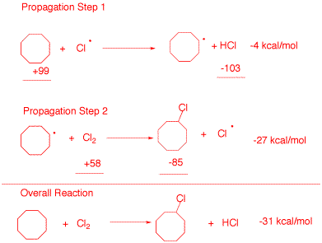

b) (10 pts.) Calculate the heat of formation of chlorocyclooctane. Data: DHfo (kcal/mol): cyclooctane, -29.7; HCl, -22.1.

*heat of rxn = heat of formation products - heat of formation of reactants*

*-31 = -22.1 + x - (-29.7)*

*-31 = 7.6 + x*

*x = -38.6 kcal/mol for heat of formation of chlorocyclooctane*

2. **Potpourri**: (40 pts., equal weight)Complete **4 of 6** of the following questions. You **must** complete a **minimum** of two problems on this page (page 3). **If you do more than four questions, cross out the ones that you do not want graded.**

1. Two equivalents of 2-methyl-2-butene react with one equivalent of BH3 in a Markovnikov fashion to form two compounds of the general structure R2BH. One is a racemate and the other a meso compound. Provide stereochemical structures of the three stereoisomers. Identify them as a d,l pair or meso. Use their R,S-descriptors.

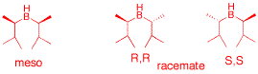

1. Provide an example of a stereospecific reaction. Explain briefly.

*Each of two stereoisomers gives two different stereoisomeric products when undergoing the same reaction. Z-2-butene upon bromination gives a racemate; the E -isomer gives a meso compound. Mechanism controlled reaction, anti addition.*

1. (R, R)-tartaric acid ([a]D = +12o) is known as the “natural” enantiomer. What is the specific rotation of a solution containing four times as much (S,S)-enantiomer as the (R,R)-enantiomer? **Show work**.

*(4-1)/(4+1) = 3/5 = 0.6 = op = ee*

*Major enantionmer pure is [-12].*

*-12 x 0.6 = [-7.6] for the specific rotation of the enantiomeric mixture.*

…continued

1. **Circle** the compound(s) that are considered **polar, aprotic** solvents.

x2-F11-str4.tif

*Correct answers: 1, 2, 5*

*Compounds 3 and 4 are both polar protic solvents.*

e) The crown ether 18-C-6 is optimal for chelation of K+ while 12-C-4 chelates Li+ well. **Draw** a crown ether having Na+ chelated efficiently.

15c5.tiff

*15-Crown-5, add a sodium cation to the center and chelate the ion with each oxygen lone pair. Na lies between Li and K on the periodic table. It is intermediate in size; requires intermediate sized crown ether.*

f) **Circle** the halides that will **not** form a stable Grignard reagent.

x2-F11-str5.tif

*Answers: 1, 2, 5. Each one has an acidic hydrogen that has a pKa less than R-H. #1is the OH, #2 the N-H and #5 CO2H.*

3. **Conformation:** (30 pts.) Consider the optically active stereoisomer of 1-bromo-3,4-dimethylcyclohexane (**1**) shown here.

a) (10 pts.) Label all centers of chirality with their appropriate R,S descriptors.

*(1S, 3R, 4R) – 1-bromo-3,4-dimethylcyclohexane*

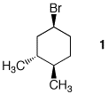

b) (10 pts.) **Draw** the chair conformations of **1** below so that the equilibrium arrows are correct. Be sure all groups are **clearly** labeled axial or equatorial. Be sure you have the correct enantiomer.

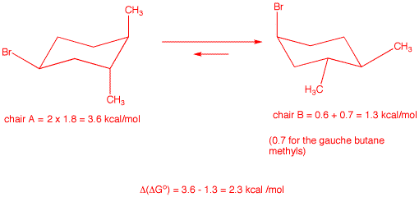

c) (10 pts.) Determine the value of Go) for the above equilibrium given the following A- values for the monosubstituted (X) cyclohexane: X = Cl = 0.5 kcal/mol; X = Br = 0.6 kcal/mol; X = CH3 = 1.8 kcal/mol; X = C2H5 = 1.9 kcal/mol; CH3/CH3 gauche butane = 0.7 kcal/mol? **Show calculations**.

*See above.*

4. **Reactions:** (20 pts.) Identify the unknown structures and answer questions in **2 of 4** of the following problems. Explain briefly. **If you do three or four problems, cross out the one that you do not want graded.**

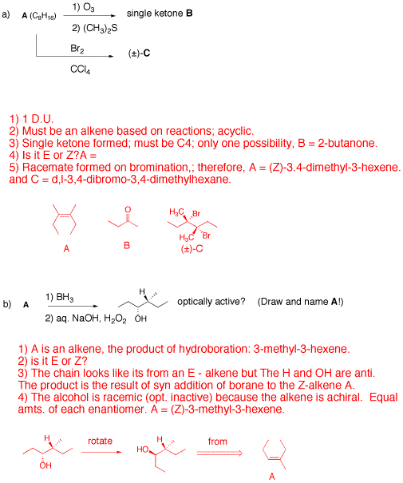

…continued

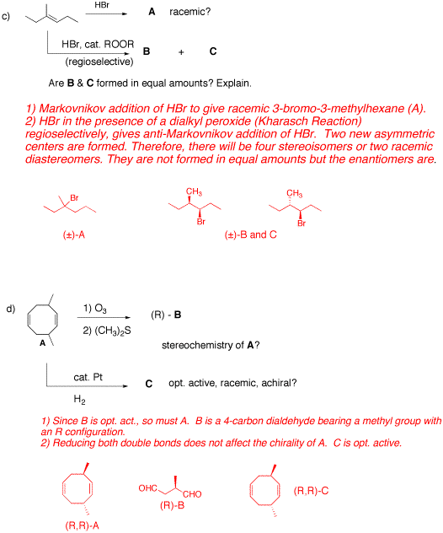

**Periodic Table**

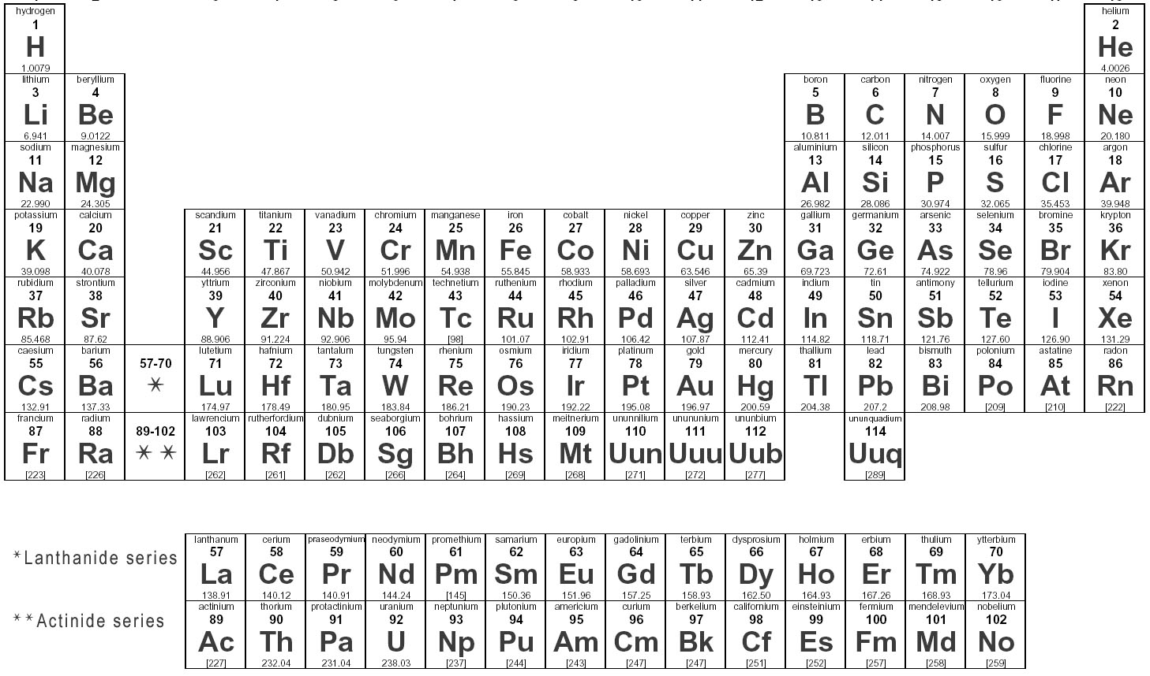

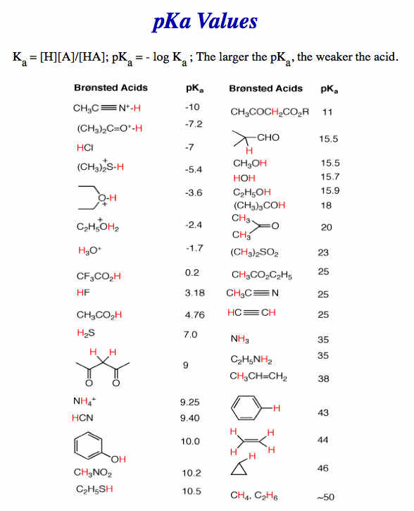

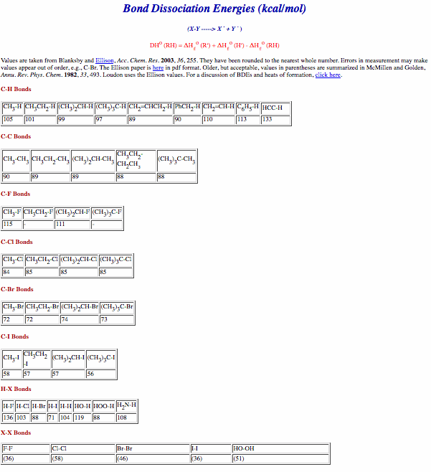

Work Sheet

Work Sheet

Work Sheet