FINAL EXAMINATION
Organic Chemistry, Chemistry 220
9 A.M.; Saturday, December 17, 2011
Answer Key

NAME (print): ______________________________________________________________

TA:_____________________ Section Day:_____________ Section Time:______________

Take a few moments to look over the exam. Do problems first with which you are most comfortable. Important points and unknowns are in bold type. Do all preliminary work on the worksheets. The worksheets will not be graded. The exam is the length of two hour exams with an additional one hour for review. Put your name on the cover sheet and subsequent pages (except for Work Sheets) where indicated. No calculators or electronic devices. A Bond Dissociation Energy Table is on page 13. A Periodic Table is on page 14.

.Remember: Neatness is to your advantage.

Have a GREAT winter break!

1) Reactions (48 pts.) Do 6 of 8 ______

2) Structure (20 pts.) ______

3) Structure/Conformation (30 pts.) ______

4) Potpourri (48 pts.) Do 8 of 10 ______

5) S_{N}2/E2 Kinetics (32 pts.) Do 4 of 6 ______

6) Heats of Formation/Combustion (30 pts.) ______

7) Synthesis (20 pts.) ______

8) Thermochemistry (30 pts.) ______

_____________________________________________________________________________

Total (258 pts)

Note: The final exam is worth 160 points toward the final grade. The grade shown above will be multiplied by 0.62 to obtain the adjusted score (258 x 0.62 = 160).

1. Reactions I: (6 x 8 pts. = 48 pts.) Complete 6 of 8 of the following questions. Pay attention to stereochemistry, etc. Identify the unknown structures and answer any questions. Give very brief explanations for your answers. If you do more than six questions, cross out the ones that you do not want graded.

…continued

2) Structure: (20 pts.) Optically inactive compound A (C₁₀H₂₀) reacts with cat. OsO₄/NMMO (N-methylmorpholine N-oxide) to produce a single, racemic compound B. Periodic acid reacts with B to form a single racemic compound C (C₅H₁₀O).

a) (15 pts.) What are the structures of A – C? Explain your reasoning.

A has 1 DU. Must be a double bond because of reactions. C has 1 DU. No C₅ ketone can be a racemate. Not enough carbons to make an asymmetric carbon. C can only be 2-methylbutyraldehyde. We have (R)-C and (S)-C to give (±)-C. But is the double bond cis or trans? It is trans as shown below. The Z-isomer would give B and B’ as SRSR and SSRR, which are diastereomers.

b) (5 pts.) Compound A does not have a plane of symmetry, yet it is optically inactive? Explain and illustrate.

A has a center of symmetry just like the anti conformation of meso-tartaric acid.
3) Structure/Conformation: (30 pts.) The monoterpene d-neomenthol [(1S, 2S, 5R)-2-isopropyl-5-methyl-1-cyclohexanol] has a specific rotation of [α]_{D} = 16⁰. [The configuration on the exam was mistakenly given as (1S, 2R, 5R), which is actually d-isomenthol. The answers to c and d were not affected. The answers here are given as d-isomenthol.]

a) (5 pts.) Draw d-neomenthol (flat structure, bold and dotted bonds).

b) (5 pts.) Draw the chair conformations of d-neomenthol on the appropriate sides of the equilibrium arrows.

c) (10 pts.) The tosylate of d-neomenthol reacts with C₂H₅ONa/ C₂H₅OH to form a single optically active compound A (C₁₀H₁₈). Catalytic hydrogenation of A forms a single, optically inactive compound B. What are the structures of A and B? Explain and illustrate. Only the chair A tosylate has an axial β-H and vicinal axial leaving group. Alkene A is opt. act. since the menthol was optically active. Hydrogenation of A creates a plane of symmetry in B.

d) (10 pts.) A sample of d-neomenthol contaminated with its enantiomer has an observed rotation of +4 degrees. What is the optical purity of the sample and what fraction of each enantiomer is present? Show work. o.p. = ee = 4/16 = 0.25 or 25%. n_{d} + n_{l} = 100; n_{d} - n_{l} = 25; n_{d} = 62.5%, n_{l} = 37.5% or n_{d} = 5/8, n_{l} = 3/8.

4) Potpourri: (8 x 6 pts. = 48 pts.) Complete 8 of 10 of the following questions. If you do more than eight questions, cross out the ones that you do not want graded.

a) Circle the species that have sp² hybridized atoms.

acetone [BeCl₃]⁻ CO₂ BCl₃ acetylene

b) Why does increased alkyl substitution of a double bond stabilize the alkene relative to some less substituted constitutional isomer? Be brief. C-H bonds of alkyl groups donate electrons to anti-bonding pi bond.

c) Circle the compound(s) that have a Degree of Unsaturation (D.U.) of 5.

C₁₂H₁₈N₂Cl₂ C₁₀H₁₇BrOS C₁₁H₁₅NO C₁₈H₃₀BrClN₄ C₈H₉NCl₂

d) Estimate the heat of formation (kcal/mol) of n-octane given that the heat of formation of n-butane is -30 kcal/mol. Show work. Each increase in a CH2 group in a homologous series makes the heat of formation more negative by 5 kcal/mol. So, the difference between n-butane and n-octane is 4 CH2’s or -02 kcal/cal. Tus -20 + (-30) = -50 kcal/mol.

e) Determine the heat of formation of an ethyl radical (kcal/mol) given the data in 4d and in the BDE table (pg. 13). [A Standard State diagram will help.]

…continued
f) Circle the acids that are readily deprotonated by methyl magnesium bromide. The Grignard reagent is the conjugate base of methane pKa = ~ 50, the weakest acid (strongest conjugate base) on our table.

(CH₃) ₂NH C₂H₂ ethanol CH₄S phenol

g) Rank the following acids in order of increasing acidity (1 → 5; least → most).

PhOH CH₃CH₂CO₂H CH₃CHClCO₂H CH₃CHFCO₂H ClCH₂CH₂CO₂H

__1___ ____2_____ ____4_____ ___5______ ___3______

h) Provide an example and briefly explain and/or illustrate how an anti-bonding molecular orbital plays a role in some organic chemical process discussed this term.

Why more alkyl substitution of double bonds gives lower heat of formation, i.e., stability. Hyperconjugation: Donation of bonding C-H sp3 hybrid into anti-bonding pi orbital of double bond.

Formation of a Grignard reagent: Addition of electron into antibonding sigma MO.

Reductive formation of 2,3-dimethyl-2,3-butanediol by active metal reduction of acetone. Add electron to antibonding pi orbital (radical anion).

i) Circle the compounds that have net molecular dipoles.

1,3-dichloro-1,2-propadiene propane (E)-dibromoethylene

1,2-dibromoethane chloroform

j) Draw the possible constitutional isomers and diastereomers of dichlorocyclobutane arising from the free radical chlorination of chlorocyclobutane. All compounds are achiral or racemic.

5) S_{N}2/E2 Kinetics: (4 x 8 pts. = 32 pts.) Complete 4 of 6 of the following questions. If you do more than four questions, cross out the ones that you do not want graded.

a) Circle the compound that reacts faster with CH₃ONa/CH₃OH in an E2 reaction. Illustrate and explain briefly. Trans decalins do not undergo chair-chair interconversion. In both structures the ring fusion methyl and hydrogen are both axial to both rings. The chlorine in the lower structure is axial, the optimal conformation for anti E2 elimination. You are not asked for the products, just which one reacts faster, which is the lower structure.

b) Circle the bromide that gives the larger E2/S_{N}2 ratio of products when exposed to C₂H₅ONa/C₂H₅OH. Explain briefly. The top structure with alpha-branching will repress SN2 reaction. It will have the higher ratio.

c) Circle the compound that undergoes E2 elimination more slowly. What is the product of that reaction? Explain briefly. C-D bonds react more slowly in E2 reaction. The upper structure will eliminate more slowly.

…continued

d) Given one equivalent of each of the sodium salts below, what is the expected product upon reaction with one equivalent 1-iodopropane? Explain briefly. The thiol anion is the better nucleophile. It will react faster than the alkoxide in an SN2 reaction competing for a limited amount of halide. The product is d-n-propyl sulfide.

e) In the S_{N}2 reaction of ethyl tosylate with LiCl, will the reaction be faster in methanol or dimethylformamide (DMF) as a solvent? Explain briefly. The reaction is faster in the polar, aprotic solvent DMF. Chloride ion is solvated (hydrogen bonding)by methanol which leaves chloride less nucleophilic.

f) In the reaction of 2-bromo-2-methylbutane with sodium methoxide or potassium tertiary butoxide, which base will give the greater ratio of Zaitsev/Hofmann product? Explain and illustrate. This example was covered in class. The less hindered base CH3ONa gives the higher ratio.
6) Thermochemistry: (30 pts. total) Create a Standard State diagram for this problem on the back of page 9 (to your left). The diagram is worth 5 points.

a) (5 pts.) Given that the hydrogenation of an alkene is exothermic, assign the heats of formation -14.8, -15.2 and -41.0 kcal/mol to 3-methylpentane, (E)- and (Z)-3-methyl-2-pentene. Explain briefly. Because hy drogenation is exothermic, 3-methylpentane must be -41.0. The E-isomers is more stable than the Z-isomer. E = -15.2; Z = -14.8.

b) (10 pts.) Given the heats of formation of CO₂ and H₂O as -94.0 and -68.3 kcal/mol, respectively, determine the heat of combustion of 3-methylpentane. Show work. C₆H_{14.}= [ 6x(-94.0) ]+[14x(-68.3)] – 41.0 = -1479.2 kcal/mol.

c) (5 pts.) Determine the heats of hydrogenation of (E)- and (Z)-3-methyl-2-pentene. Show work.
E = -41.0 – (-15.2) = -25.8 kcal/mol
Z = -41.0 – (-14.8) = -26.2 kcal/mol

d) (5 pts.) Determine the heat of combustion of (Z)-3-methyl-2-pentene without using the heat of formation of CO₂. Show work. In part b, add -41 to -1479.2 to get the value -1520.2 for the heat of combustion of 6C + 7H2O. But combustion of the Z-alkene yields one less mole of H2O. Therefore 6C + 6H2O = -1520.2 –(-68.3)= -1451.9. Subtract -14.8 for the heat of formation of the Z isomer gives -1437.1 kcal/mol.

7) Synthesis: (20 pts.) Design a synthesis of 2-methylcyclohexanone. Only methane and cyclohexane are available as the sources of carbon for the target molecule. All organic and inorganic reagents are available to you. This is the best route. The epoxidation may also be accomplished by halohydrin formation followed by treatment with base. Chlorination of methane or bromination of cyclohexane is also acceptable. Other chromium oxidants or Swern oxidation are OK.

8) Thermochemistry: (30 pts.)

- (20 pts.) Provide the two propagation steps for the free radical monochlorination of 2,2-dimethylpropane (neopentane) using the bond dissociation energies in the BDE Table (pg. 13). Place the reactants and products in the appropriate boxes and the BDEs on the lines. Calculate the heat of each propagation step and the heat of the overall reaction. The BDEs in the table are slightly different from those used during the term.

b) (10 pts.) Calculate the heat of formation of 1-chloro-2,2-dimethylpropane. Data: ΔH_{f}º (kcal/mol): neopentane, -40.2; HCl, - 22.1.

ΔH_{f}º (rxn) = H_{f}º (products) - H_{f}º (reactants)

-27 = (x -22.1) – (-40.2 + 0)
-27 = x -22.1 + 40.2
-27 = x +18.1
x = H_{f}º (RCl) = -45.1 kcal/mol

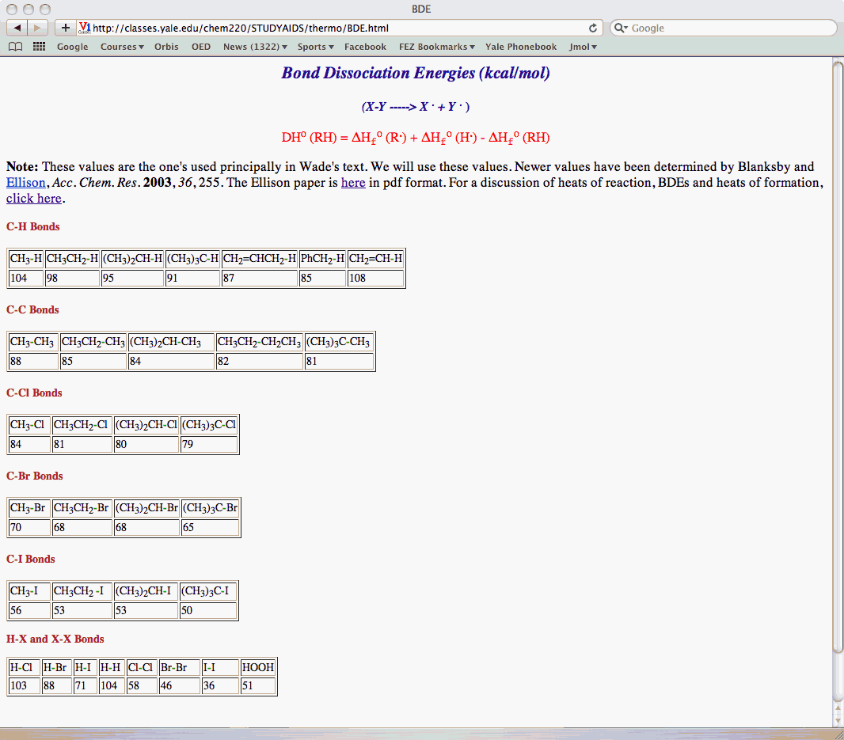

Periodic Table

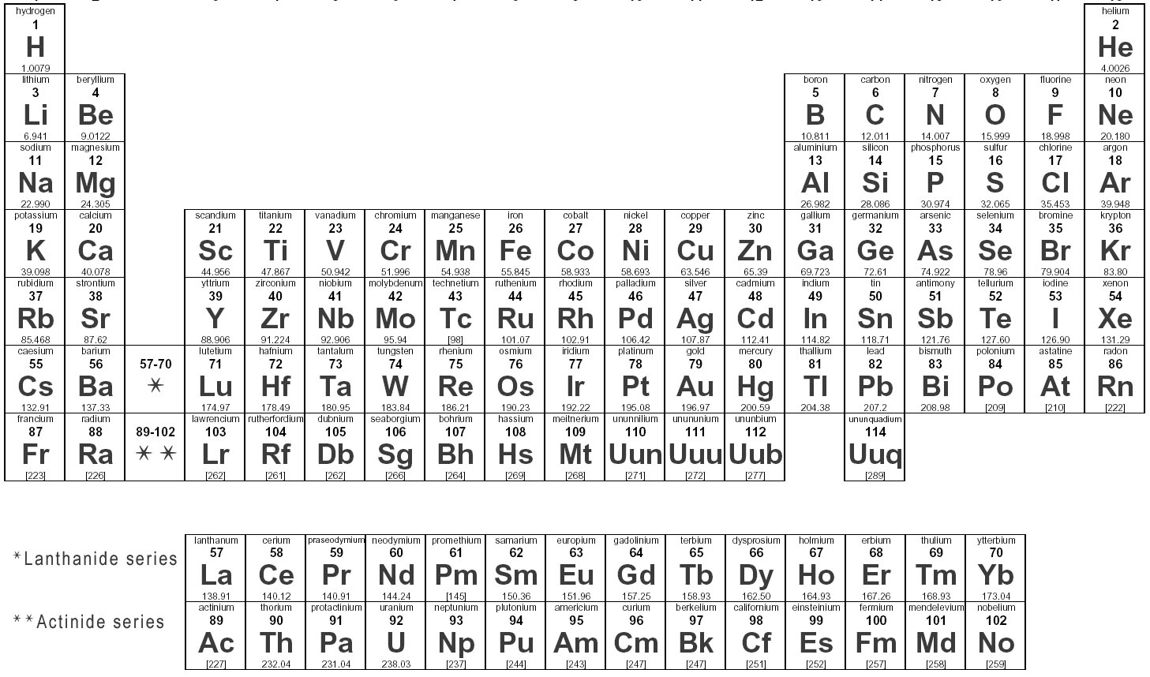

Work Sheets

Work Sheets

Work Sheets

Work Sheets

