FINAL EXAMINATION
Organic Chemistry, Chem 220
2:00 P.M.; Sunday, May 5, 2013

Solutions
(Some illustrations have not been included)

NAME (print): ______________________________________________________________

TA:_____________________ Section Day:_____________ Section Time:______________

No calculators, electronic devices, texts or notes. You may use molecular models. Take a few moments to look over the exam. Do problems first with which you are most comfortable. Important points and unknowns are in bold type. Do all preliminary work on the worksheets. The worksheets will not be graded. The exam is the length of two hour exams with an additional one hour for review. STOP writing when you are asked to do so. Put your name on the cover sheet and subsequent pages (except for Work Sheets) where indicated. A Periodic Table and a Bond Dissociation Energy table are on pages 16 and 17, respectively.

.Remember: Neatness is to your advantage.

Have a GREAT summer! Keep up-to-date for Chem 230.

1. Structure (25 pts) _________

2. Reactions I (32 pts; 4 of 6) _________

3. Potpourri (40 pts; 8 of 10) _________

4. Synthesis (25 pts.) _________

5. Thermochemistry (25 pts.) _________

6. Reactions II (30 pts; 6 of 8) _________

7. Kinetics/
Thermodynamics (20 pts.) _________
(2 of 4)

8. Mechanism (25 pts.) _________

_____________________________________________________________________________

Total (222 pts)

Note: The final exam is worth 160 points toward the final grade. The grade shown above will be multiplied by 0.72 to obtain the adjusted score (222 x 0.72 = 160).

1. Structure : (25 pts.) Compound A (C₇H₁₂) reacts with HBr/ROOR (Kharasch Reaction) to give stereoisomeric compounds B and C. When compound B is treated with aqueous KOH, compound D (C₇H₁₂) is formed. Under the same conditions compound C forms both A (major) and D (minor). Ozonolysis and dimethyl sulfide reduction of D gives E. Reduction of E with NaBH₄ gives 2-methylhexan-1,6-diol. Alternatively, treatment of A with cat. OsO₄/HIO₄ produces F (C₇H₁₂O₂). Reduction of F with LiAlH₄ affords heptan-1,6-diol. What are the structures of A-F? Pay attention to stereochemistry. Provide brief mechanistic explanations for the formation of A and D from C and D from B.

The two diols whose names are given lead us back to the dicarbonyls E and F which tell us that we are not only dealing with two cyclohexenes but also the position of the double bond in the ring. A and D are defined. B and C are formed by bromine radical addition to give a tertiary radical that abstracts a hydrogen atom from HBr. In both B and C the reacting conformation must have bromine axial for E2 elimination. C has two beta-axial hydrogens (two products); B has only one (one product).

2. Reactions I: (4 x 8 pts. = 32 pts.) Do 4 of 6. Provide the reagents that effect the following transformations. I have listed the number of steps that I would use. Your count may be different and valid. If you do more than four problems, cross out (with a large X through the solution) the ones that you do not want graded.

…continued

3. Potpourri: (8 x 5 pts. = 40 pts.) Do 8 of 10 problems. If you do more than eight problems, cross out (with a large X through the solution) the one(s) that you do not want graded.

i) Circle the greatest number of compounds that are at the same oxidation level.

ii) Explain briefly an example how anti-bonding orbitals play a role in organic chemistry.

More substituted double bond with alkyl groups; more stable. Occupied sigma C-H bond donates electrons to vacant antibonding pi orbitals. Just one example.

iii) Ibogamine, of the film Good Will Hunting fame, has the formula C₁₉H₂₄N₂. How many rings and double bonds are present? Show work.

Formula the equivalent of C₂₁H₂₆. Most saturated alkane is C₂₁H₄₄. 44 – 26 = 18/2 = 9 rings and pi bonds.

iv) The specific rotation of (S,S)-tartaric acid is [α] = -12º. What is the percentage of each enantiomer in a mixture of the two enantiomers that has [α] = +3º. Show work.

Major component must be (R,R)-tartaric acid. 3/12 = 0.25. A – B = 0.25; A + B = 1.0. A = 0.625, B = 0.375. R.R = 62.5%; S,S = 37.5%

…continued

v) The ratio of alkenes formed by the E2 elimination of 2-bromo-2-methylbutane need not be the same as the ratio formed when the bromide undergoes E1 elimination during solvolysis. Explain.

E2 is kinetically-controlled. No mechanism (too high an energy barrier) with base to equilibrate isomers. The distribution of alkene products is determined by the difference in activation energy of the two transition states (e.g.; Zaitsev vs. Hofmann products. In E1 eliminations, acid is formed as a by-product. Acid can equilibrate (thermodynamic-control) alkenes via carbocations. The position of the equilibrium is determined by the difference in the Δ(ΔGº) of the products. Notice that product A is formed faster than product B even though A is less stable than B. In some other case, product A may lie lower (more stable) than B in terms of thermodynamic stability. If the reaction is irreversible, then the ratio A/B is kinetically controlled.

vi) Provide a diagram that relates bond dissociation energy and heat of formation for a generic alkane, R-H.

…continued

- In the free radical chlorination of (S)-1-chloro-2-methylbutane to form dichloropentanes, draw the dichloride(s) that is (are) no longer optically active. Give a ONE WORD explanation why it (they) is (are) no longer optically active.

Chlorination of the methyl group makes two groups the same. Achiral product. Abstraction of the tertiary hydrogen gives a planar radical which reacts with chlorine to give a racemate.

- Circle the “acids” that are deprotonated by 1-lithiobutyne.

NH₃ NH₄Cl CH₃OH H₂O CH₄S

(CH₄S is CH₃SH)

- Provide an example wherein deuterium labeling provides mechanistic information in organic chemistry.
- Mechanism of Swern oxidation
- Isotope effect in chlorination of methane vs. perdeuteromethane.
- Isotope effect in E2 elimination.

- What do the figure 8 knot and the anti conformation of meso-HO₂CCH(OH)CH(OH)CO₂H have in common? Explain and illustrate.

Both have a center of symmetry.

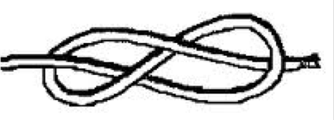

4. Synthesis: (25 pts.) We have discussed the pinacol rearrangement in class in the context of 1,2-diols 1 and 2. Design a synthesis of 1 or 2 from cyclohexanone and methyl bromide. All other reagents are available to you. No mechanisms are required. A few concepts that may apply are: C-C bond formation; stereoselective formation of 1,2-diols; hydroboration and oxidation.

The best approach is to prepare 1,2-dimethylcyclohex-1-ene. This way one has easy access to either diol. Methyl Grignard addition to cyclohexanone and E1 dehydration provides 1-methylcyclohexene. Hydroboration and oxidation gives a new ketone, 2-methylcyclohexanone [Note: The alakine peroxide step is actually not needed. One can oxidize the borane intermediate directly with CrO₃ to form the ketone.] Repeat the Grignard addition and dehydration. OsO₄ gives the cis-diol. Peracid affords the epoxide, which is opens in an anti-fashion with aqueous acid.

5. Thermochemistry: (25 pts.)

a) (15 pts.) Determine the heat of formation of chlorocyclohexane prepared by the free radical chlorination of cyclohexane. Provide the two propagation steps and the overall reaction for this process. Place the reactants and products in the appropriate boxes. Compute the heats of each reaction using the data in the BDE Table (pg. 17).

b) (10 pts.) Calculate the heat of formation of chlorocyclohexane using the following data: ΔH_{f}º (HCl) = -22.1 kcal/mol; ΔH_{f}º (cyclohexane) = -29.5 kcal/mol. Show work.

heat of rxn. = heat of products – heat of reactants

-30 = (x + (-22.1)) – ((-29.5) + 0)

x = -37.4 kcal/mol

6. Reactions II: (30 pts.) Do 6 of 8. Provide structures for the unknown compounds AND answer the ? marks. Be explicit about stereochemistry, optical activity, racemates, etc. No mechanisms required! If you do more than 6 problems, cross out (with a large X through the solution) the one(s) that you do not want graded.

…continued

7. Kinetics/Thermodynamics: (20 pts.) Do one from pg. 12 and one from pg. 13. Keep your answer short and to the point! If you do more than two problems, cross out (with a large X through the solution) the one(s) that you do not want graded.

a) “The more stable conformation of a compound is always the one that reacts faster because there is more of it.” True or False? Provide an example.

False! Consider bromocyclohexane. The equatorial bromide is present in greater concentration than the axial conformer but it is the axial conformer that reacts faster in an E2 elimination.

b) Explain the difference between a kinetically-controlled and thermodynamically-controlled reaction. Be brief. A diagram will help.

See 3v. E2 elimination is an example of a kinetically controlled reaction. The amount of different alkenes is a function of the activation energy barrier. The stability of the products is irrelevent because the reaction is not reversible. An SN1 reaction of a tertiary halide in water that leads to mainly an alcohol and some alkenes is thermodynamically controlled because all products are in equilibrium. Recall that HBr is formed which is the agent for equilibration.

…continued

c) In the S_{N}1 solvolysis reaction of tert-butyl bromide the rate is expressed as k[RBr]. The solvent does not enter the rate expression. Explain and illustrate briefly.

There is so much solvent that its concentration doesn’t change much. The rate-limiting step is the ionization.

d) What is the Hammond Postulate? Briefly explain and illustrate.

Exothermic reaction has early transition state.

Endothermic reaction has late transition state.

8. Mechanism: (25 pts; equal weight) In PS9, exam 3 and in class (4/15 and 4/29) we considered the Stevens oxidation using aqueous NaOCl in acetic acid (HOCl). The authors observed that 2º-alcohols are oxidized much faster than 1º-alcohols. In a subsequent paper the authors demonstrated this selectivity by converting diol 1 into keto alcohol 2. I suspect that they prepared diol 1 from the enantiomer of the monoterpene α-pinene (3).

- How would you convert 3 to 1?

1) O₃; Me₂S or OsO₄/HIO₄
2) NaBH₄ or LiAlH₄

- Give the two R, S-designations in diol 1. (Ignore the secondary alcohol carbon since 1 is a mixture of optically active diastereomers.) Put your answer by structure 1.

- In the Stevens’ paper of PS9 a table showed that the primary alcohol, n-decyl alcohol (1-decanol), was efficiently converted into the ester, n-decyl decanoate (C₂₀H₄₀O₂) in the presence of aq. NaOCl/HOAc. Provide a mechanism for this reaction. [Use R = C₉H₁₉; RCH₂OH = n-decanol] [ORGO, alcohols, #3, exam 3; also discussed in class on 4/15 and 4/17.]

As the aldehyde is being formed by by oxidation, unreacted alcohol adds to the aldehyde (hemiacetal). The hemiacetal looks like a secondary alcohol. It is oxidized to the ester.

See the answer to 3a in Exam 3 at this link.

http://classes.yale.edu/chem220/STUDYAIDS/oldexams/exams-S13/x3-S13-ans.htm

- In the second paper the authors demonstrated that methanolic NaOCl/HOAc was capable of oxidizing heptanal (n-heptyl aldehyde) to methyl heptanoate (n-C₆H₁₃CO₂CH₃). The success of this reaction tells you what about the rate of oxidation of methanol relative to primary alcohols and secondary alcohols using this oxidant? Be brief.

Methanol is slower to oxidize than other primary alcohols. If not, chlorine would oxidize methanol. This is not an esterification. Same mechanism as 8c.

- Do you think that the oxidation in d) will work successfully in the conversion of oleic aldehyde [(Z)-octadec-9-enal] to methyl oleate? Explain and illustrate.

No. Chlorine water can do two reactions. One is Stevens oxidation to methyl oleate. The success of the reaction requires oxidation to be much faster than chlorohydrin formation using one equivalent of chlorine. Alternatively, if chlorohydrin formation is faster than oxidation, all hope is lost

Periodic Table

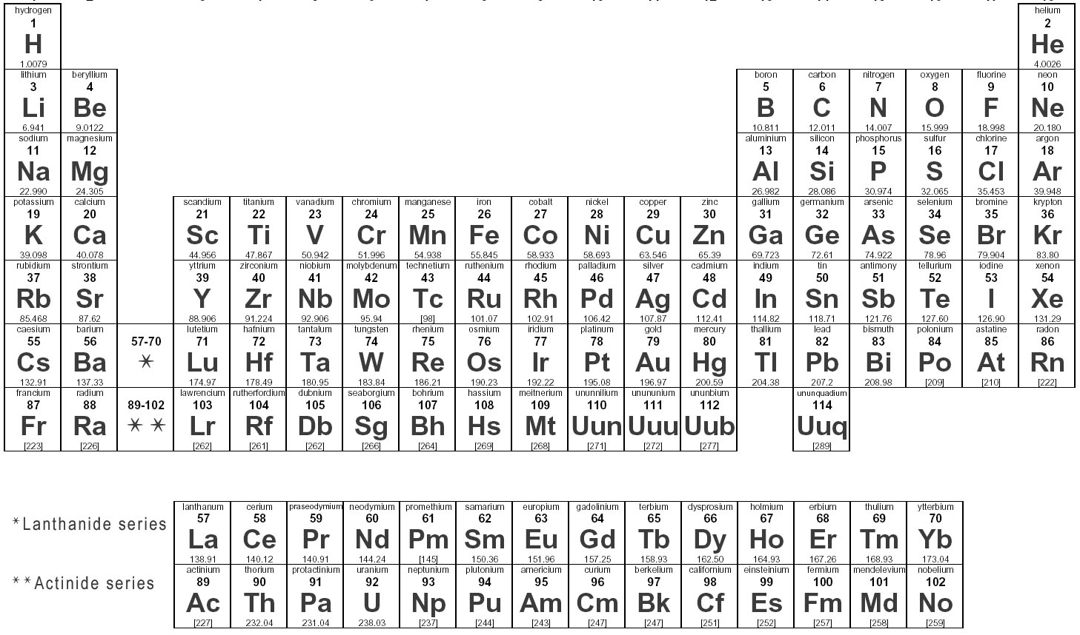

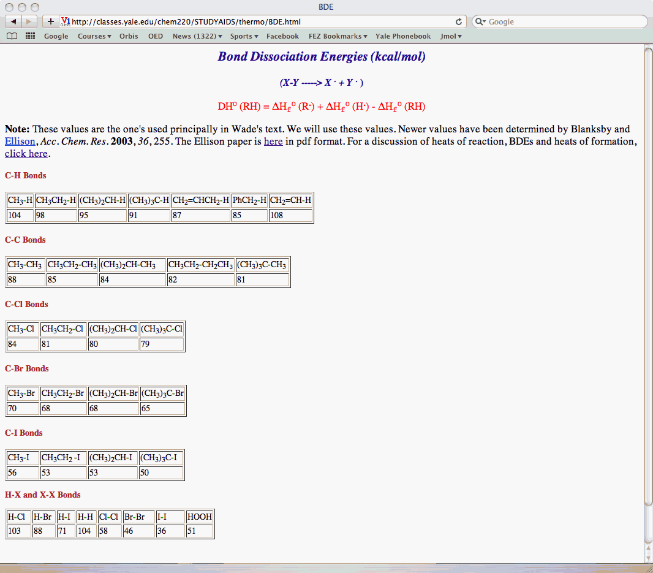

Work Sheets

Work Sheets

Work Sheets

Work Sheets

